Tutorial 10 SQL – Advanced SELECT statement

- List 5 aggregate functions that can be applied on columns of multiple rows.

- Explain the usage of GROUP BY clause.

- Refer to the HR Schema in the Appendix of Tutorial 9, Write SQL query that fulfill the requirements:

  - Count number of different departments in the employees table. (11)

  - Show the number of employees that earn commission points (commission_pct does not contains a null value)

  - List the deportment_id and number of employees in each department. Sort the result in ascending order of department id.
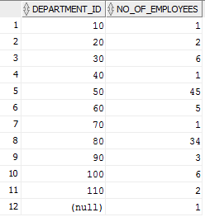

  - List the department name, and the number of employees in each department. List the department with the largest number of employees on top.
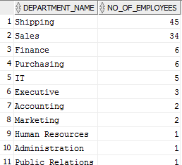

  - For those Jobs that have more than 4 employees, list the job ID, number of employees of the job, highest, lowest and average salary of the job. Show the result according the descending order of number of emplyees.

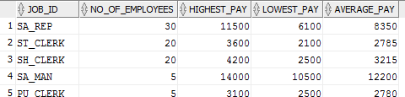

  - (Optional) List the country name and the number of employees in the country.

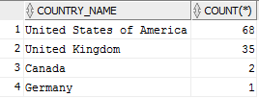
  - (Optional) List the job ID and employee ID for all employees who earned more than the average salary of his/her job ID.
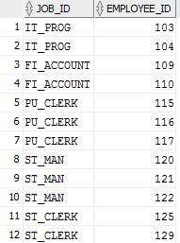
  - (Optional) List the employee first name along with the employee’s manager first name.
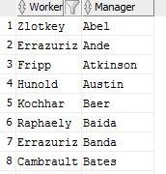

  - (Optional) List the department ID, department name with the employee ID and first name of the manager, including departments without a manager.

